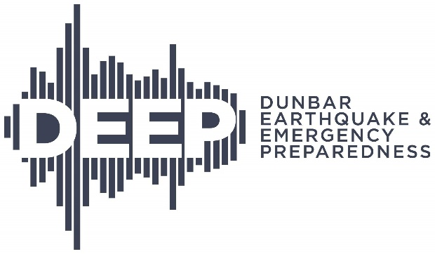

Report on May 2, 2026 Wildfire/Emergency Preparedness Open House

With the assistance of the $500 grant from FireSmart Canada, Dunbar Earthquake and Emergency Prepredness (DEEP) organized and hosted a successful Wildfire/Emergency Preparedness public education event on May 2, 2026. The event marked Wildfire Community Preparedness Day and the start of Emergency Preparedness Week.

The event was co-hosted by FireSmart BC, and was held outdoors by DEEP’s Disaster Support Hub in Memorial Park, in the Dunbar community of Vancouver. It was open to the public from 10:30 a.m. to 1 p.m.

The Open House featured information booths and demonstrations by 12 community partners: BC Hydro, FireSmart BC, Vancouver Fire Rescue Services (VFRS), Canadian Red Cross, the Metro Vancouver Wildfire Emergency Operations team, Pacific Spirit Park Society, Pacific Spirit MedVents, VECTOR HAM radio operators, Survive-It (an emergency preparedness consultant), Total Prepare (a supplier of emergency preparedness products), Kerrisdale Oakridge Marpole Community Policing Centre, and DEEP. A small fire engine was also on site for children to explore.

The event attracted approximately 125 visitors and participants. Attendees learned about our community’s vulnerability to urban wildfire, steps they can individually and collectively take to reduce that risk, and how to be ready for evacuation if needed. They received information about how to prepare for the risk of house fires caused by a major earthquake or by a forest fire in nearby Pacific Spirit Park.

Our local FireSmart coordinator Christian Craig and his team from VFRS provided the public with important information about how to ‘firesmart’ their properties to reduce the potential impacts of wildfire on their homes and neighbourhood. They distributed printed materials from FireSmart BC and other agencies, and discussed the importance of home emergency kits and fire extinguishers.

DEEP and VECTOR demonstrated how the Disaster Support Hub operates as an emergency communications centre for our community when an emergency occurs, sharing critical information about food, water, sanitation and first aid. We also help Vancouver’s Emergency Operations Centre direct first responders to where they are needed most.

DEEP distributed approximately 170 pamphlets on emergency preparedness topics, in multiple languages. The other participating organizations also provided informative handouts about fire and emergency preparedness as well as the resources available to the public when a disaster occurs.

We are very grateful for the support of the FireSmart Canada grant which covered the costs of printing to advertise the event in our community (see the attached poster), public education materials, as well as refreshments for the volunteers from the participating organizations.

